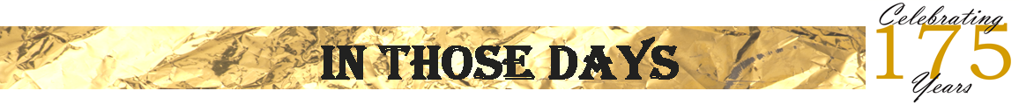
In a special edition of “In Those Days”, we celebrate the 100th birthday of life long St. Boniface Parish member, Ethel Stephan. Ethel was kind enough to write the following…
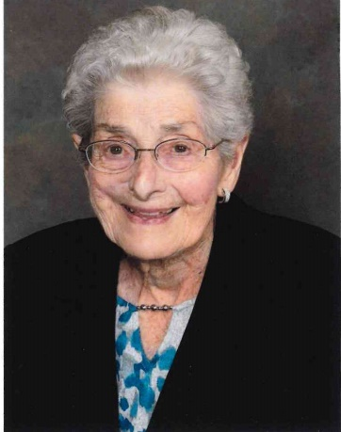
On September 30, 1922 a baby girl, Ethel, was born to John C. and his wife Emma (Baumgartner) Heisdorf at Dr. Urkhart’s Hospital located in West Bend. Yes, there was a Dr. Urkhart Hospital in those days, consisting of several rooms for medical treatment, and yes, the doctor had a nurse. Emma’s brother, John Baumgartner, was a dentist and had an office on the second floor of the same building. The building was located on Main Street and had businesses on the first floor.
On the next day, October 1, 1922, Dr. John Baumgartner put his wife, Veronica (Zwaska) Baumgartner and the baby girl into his car and drove to Saint Boniface Catholic Church at Goldenthal where the baby sponsors being Uncle Johnny (aka Dr. John Baumgartner) and Aunt Veronica. Ethel is still wondering what clothes she wore for the baptism since she was taken straight from the hospital. The baby was given the name Ethel because the baby’s father had seen Ethel Dare perform walking on the wing of a slow flying one wing airplane at the Wisconsin fairgrounds in Milwaukee. Ethel Dare’s real name was Marge Hobbs.
Ethel’s nickname was Girlie and was called this by all the people in Richfield, because she was the first girl born to the family since her brother was born six years earlier in 1916. Her brother, also named John, was nicknamed Butz.
Ethel is a lifetime member of Saint Boniface Parish. She started school there in third grade because there was no transportation to get there for the first and second grade. Ethel was able to walk to the Richfield School for first and second grade, though she got in trouble for not arriving to school on time because she would pick wildflowers on the way. At the end of the second grade, the annual picnic was being held and the big boys were playing softball. Ethel was watching with the rest of the children when one of the Jacklin twins hit a ball and it hit Ethel near an eye, knocking her out. She awoke with the school principal, Ralph Janusch, holding her, putting ice on her face. She then walked around the streets of Richfield for some time with a black eye.
Her parents were very involved with the church. When it was time to mow the cemetery, Ethel’s father used a reel type push mower. He mowed the children’s burial area as well as the relatives’ and other graves. Ethel and her sister Joanne had to rake the mowed area and cut off the 10-inch weed growth when the mower did not cut sufficiently. They also had to trim around the stones encircling each baby grave. Presently, Ethel’s son John and daughter Jane perform perpetual care at the gravesites with the filling of topsoil around the grave settings and scrubbing the memorial stones of the mossy fungus.
Sr. Adeline Loebe, sssf with Joseph, Joanna and Ethel Heisdorf.

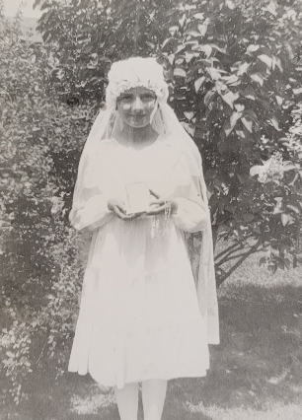
Ethel graduated from Saint Boniface School with a class of 6 students in 1936 and from Holy Angels Academy High School in Milwaukee in 1940. She finished her education at Spencerian Business College in Milwaukee in 1942. Ethel met her husband Walter in the third grade while attending St. Boniface. Walter Stephan and Ethel were both graduates of Saint Boniface eighth grade class in 1936. They married on May 19, 1945. The couple was childless for twelve years.
During that time, she made use of her Spencerian College education by taking an office position at the Red-E Tractor Company, Richfield. Walter worked as a machinist at Gehl Company, West Bend and with his brother John on his mother’s farm. Walter’s father had passed away when he and his five brothers were young. Walter was ten years old. (In later years, Walter’s son, Mark Stephan, purchased the farm from his uncles.)
1st Communion
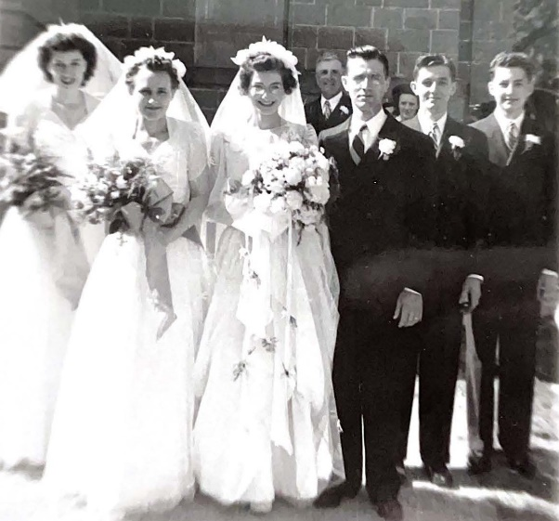
A change of doctors and a new aunt, (when one of Walter’s uncles remarried after his wife had died), brought new hope for pregnancy. The new aunt gave Ethel the Saint Gerard prayer for expectant mothers, and the family increased from none to two boys and three girls. Each boy has the middle name Gerard, and each girl has the middle name Geralyn in honor of this patron saint. Ethel has another thing to celebrate. She survived cancer after having radiation treatments. The treatments did the job but also did some damage which she has to live with. Walter passed away July 22, 2007 after 62 years of marriage.
Graduation – Ethel is third from the right.
Ethel’s memberships during her 100 years at Saint Boniface included the Young Ladies Sodality and the Married Ladies Society. She helped when they needed to clean the church and school, baking for monthly card parties, and multiple activities.
Ethel’s connections with Saint Boniface are also related to her great grandparents, Fridolin and Wilhelmina (Motsch) Baumgartner who are buried in the Saint Boniface cemetery. They had emigrated from Germany and arrived in New York on March 16, 1846, on the Nathaniel Hooper ship from New Haven, France. Fridolin Baumgartner purchased 40 acres of land for $300 in the Town of Polk on August 2, 1846, five months after arriving in the United States. That is the same year that Saint Boniface Parish originated. In addition to her great grandparents, Ethel’s grandparents, Henry and Charlotte Baumgartner, her parents John C. and Emma Heisdorf, sisters Joanne and Jeanette, and husband Walter Stephan are also all laid to rest in the cemetery here at St. Boniface on the north side of the school. Her older brother Butz’s burial was in Kewaskum and a younger brother Joseph is buried in Montana . –Thank you, Ethel, for sharing your faith journey with the parish community!
May 19, 1945

